

DriveStats

Functional Requirements Documentation



Department of Computer Science. University of Pretoria

**Axel Ind**: 12063178

**Nick Robinson**: 12026442

**Tim Kirker**: 11152402

**Zander Boshoff**: 12035671

**William Seloma**: 10155865

https://github.com/AxelInd/COS301_DriveStats/

Contents

High Level Class Diagrams 3

Client Side Android Functionality 3

Server Side Functionality 4

Database Diagram 5

Use Cases 6

Critical 6

userRegistration 6

userLogin 8

TripMonitorState 10

Important 12

DisplayTripInformation 12

Nice-To-Have 14

viewComparedResults 14

Bibliography 18

# High Level Class Diagrams

## Client Side Android Functionality

This section refers to the mobile application aspect of the DVT DriveStats program. This details the use of activities, external application requests, sensor data aggregation, and their respective management.

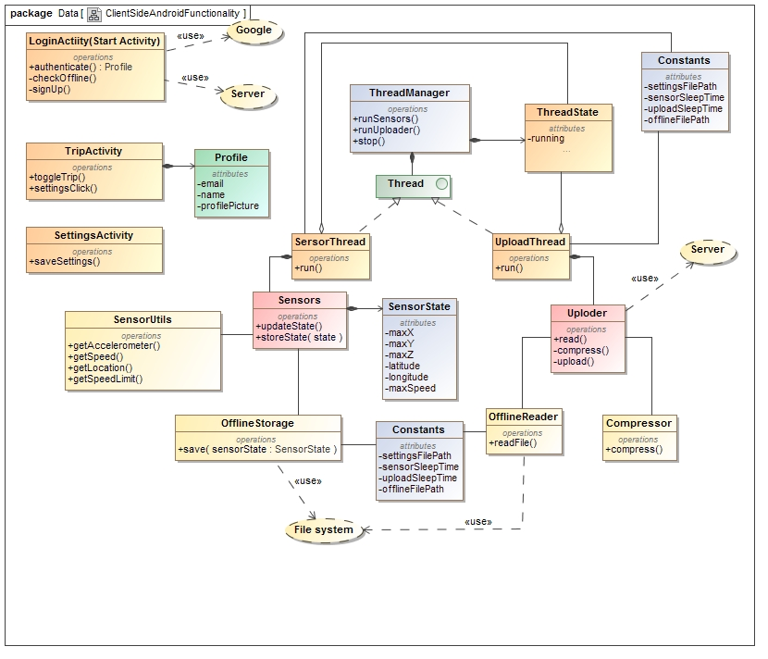

Figure - Client-Side Class Diagram

## Server Side Functionality

This section refers to the server-side implementation of the database manager. The server is responsible for several tasks, including but not limited to, Object Relations Mapping, Equation Coefficient storage, login-authentication, user registering, and statistical and meta-statistical calculations

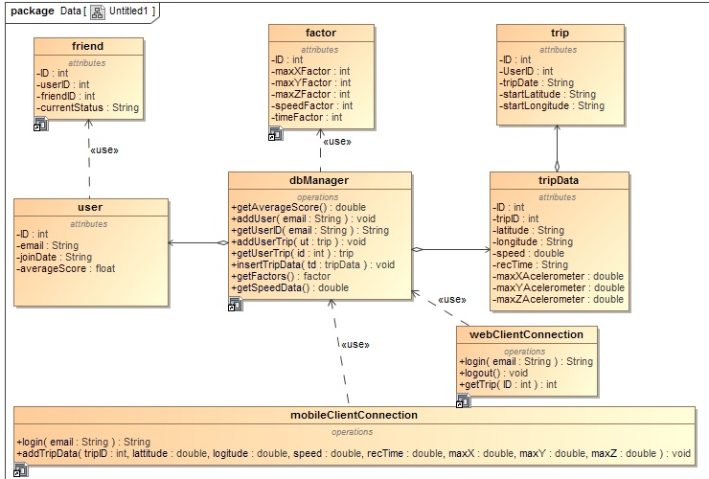

Figure - Server-side Class Diagram

## Database Diagram

Tables relate to the storage of data, description of metadata, and algorithmic modifiers

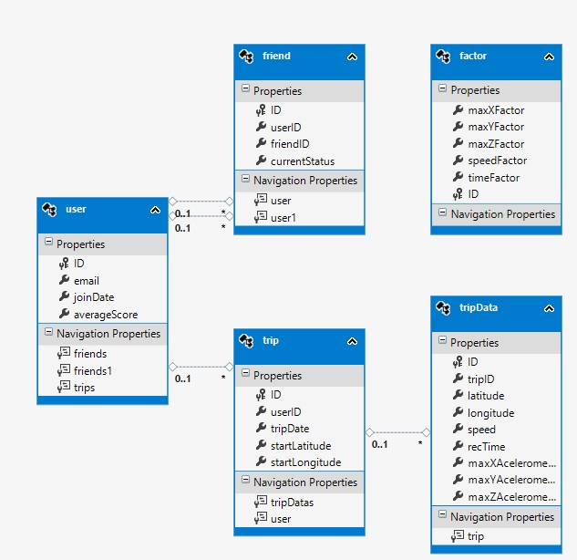

Figure - Database Organisation Description

# Use Cases

All use cases described here-in are in direct compliance with the initial specification as released by the company, DVT (DVT, 2015). As expounded upon the first meeting with the client.

## Critical

### userRegistration

#### Description

This use case will be used by the android client and the web interface to allow new users to save their information in the database.

#### Use Case

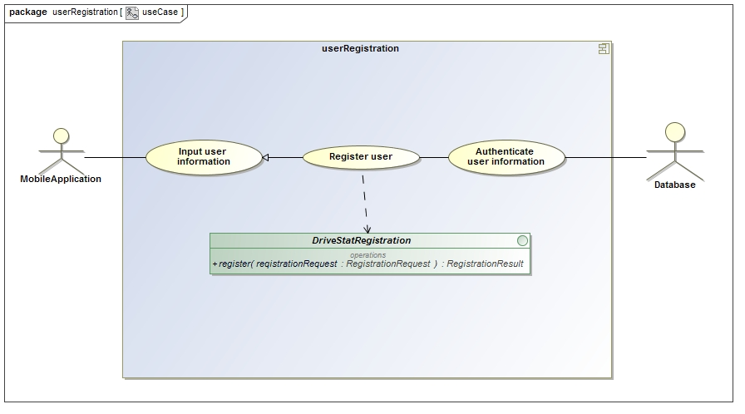

Figure - User Registration use case diagram

#### Service Contract

The Service contract for the userRegistration service is shown in Figure x. This is a simple database element creation service.

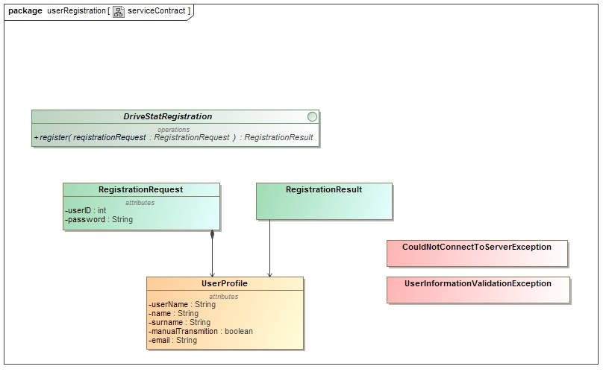

Figure - User Registration service contract

#### Process Specification

The process specification contract for the userRegistration service is shown in Figure x. This is a simple database element creation specification.

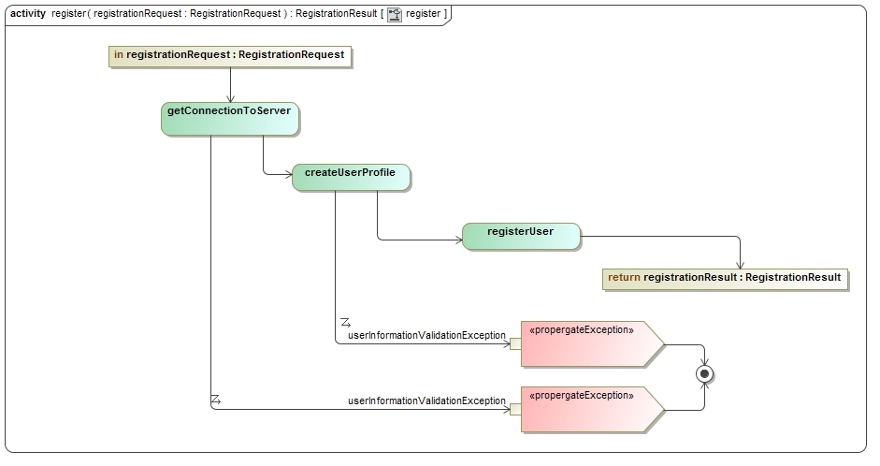

Figure User Registration process specification

### userLogin

#### Description

This use case will be used by the android client to initiate login, via the server, for use on the client-side Android application. This use case extends to direct login of a system admin for server manipulation.

Use case

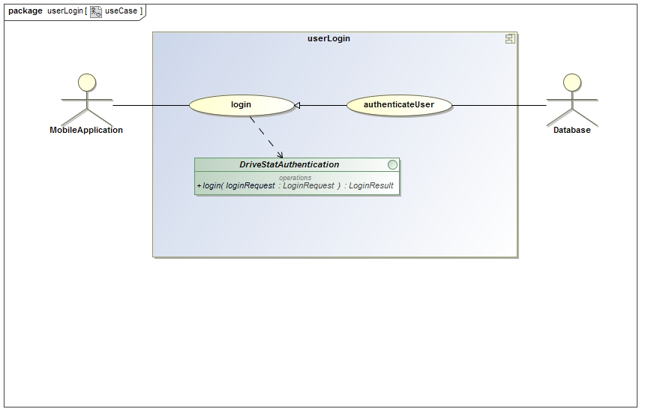

Figure - User Login use case

#### Service Contract

This service contract outline the process used by the android client to initiate login, via the server, for use on the client-side Android application. This contract extends to description of the direct login of a system admin for server manipulation.

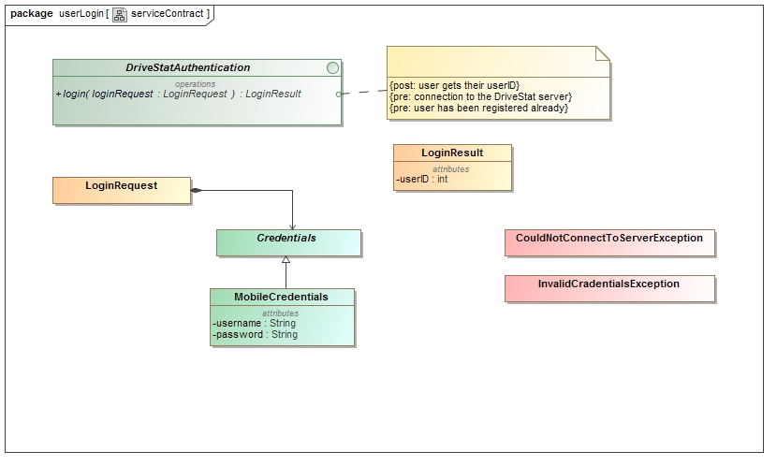

Figure - User Login service contract

#### Process Specification

This process specification outline the process used by the Android client to initiate login, via the server, for use on the client-side Android application. This specification extends to process description of the direct login of a system admin for server manipulation.

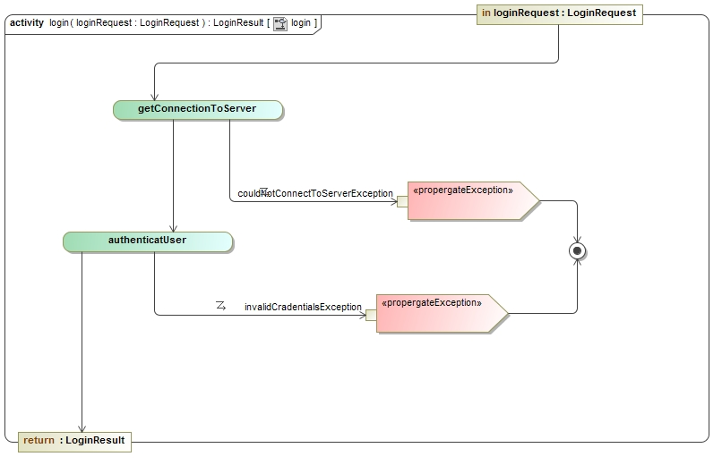

Figure - User Login process specification

### TripMonitorState

#### Description

This use case will be used by the user to activate and deactivate the monitoring of the phones sensors.

#### Use cases

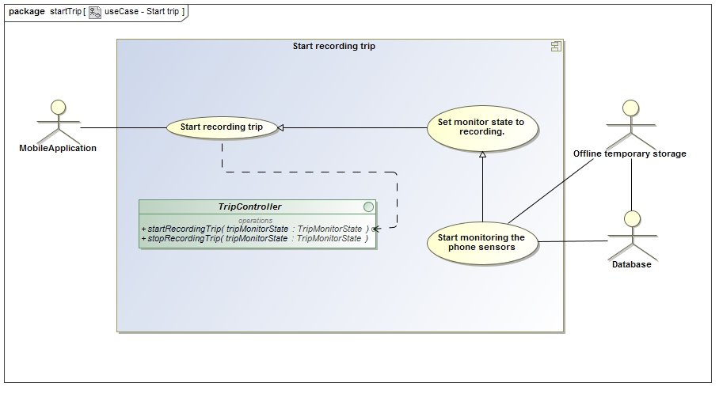

Figure - Start Recording Trip use case

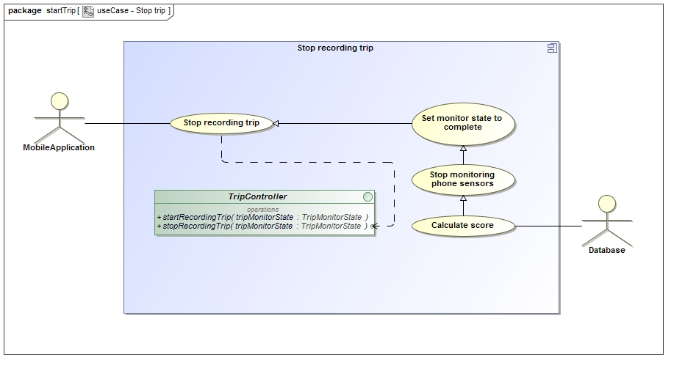

Figure - Stop Recording Trip use case

#### Service Contract

The Service contract for the Trip Recording service is shown in Figure x. This is a dual functioned service providing sensor monitoring and feedback to the database.

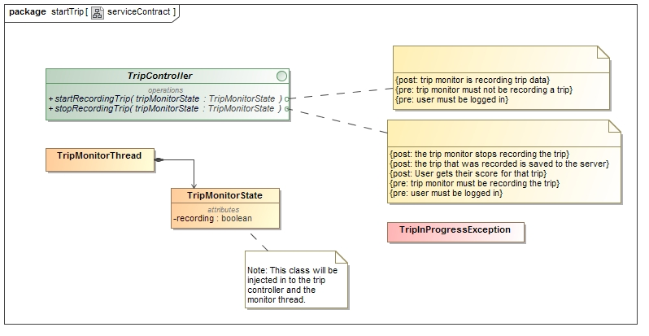

Figure - Start Trip service contract

#### Process specification

The process specification for the Trip Recording service is shown in Figure x. This is dual-functioned specification outlining sensor monitoring and feedback to the database.

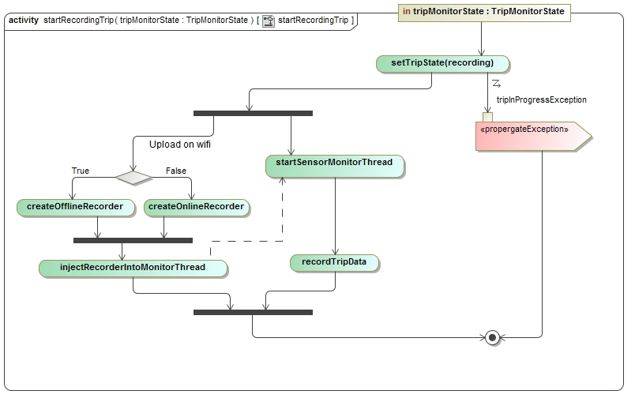

Figure - Start Recording Trip service contract

## Important

### DisplayTripInformation

#### Description

This use case will be used by the user to receive a graphical display of the use information from their current trip.

#### Use case

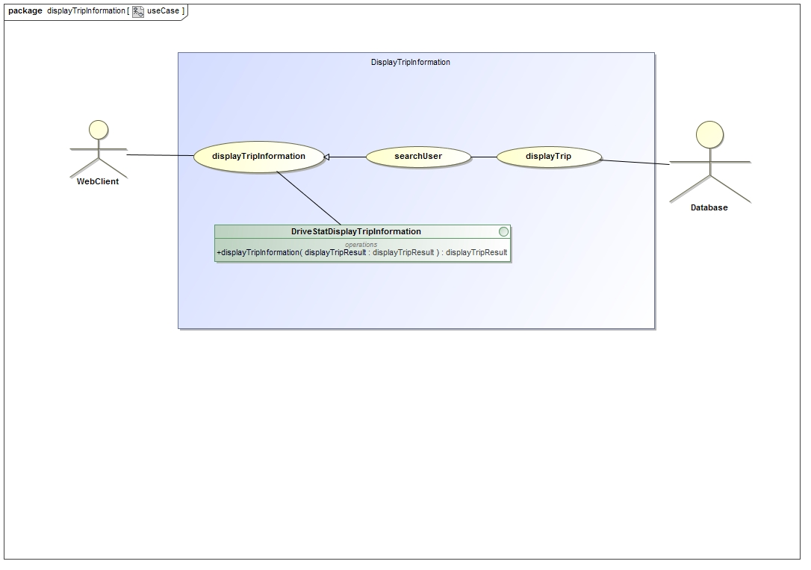

Figure - Display Trip Information use case

#### Service Contract

This service contract describes the mechanism by which the user will receive a graphical display of the use information from their current trip.

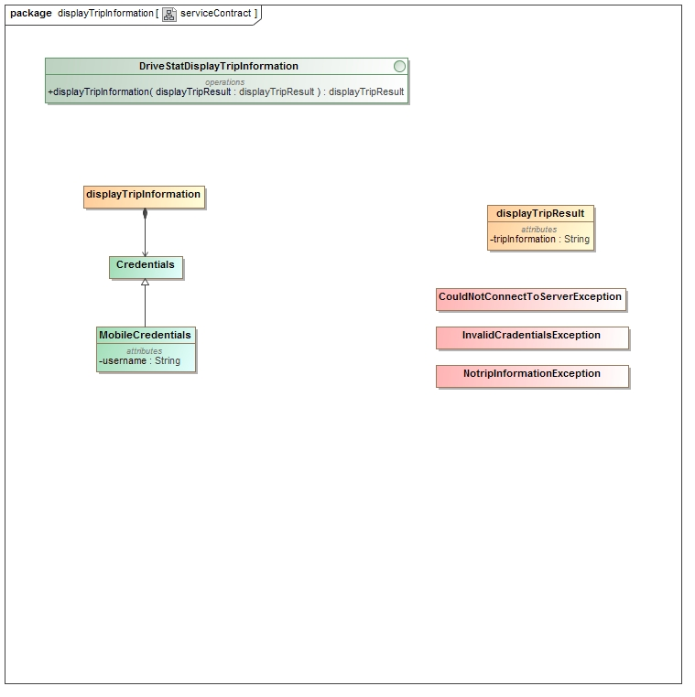

Figure - Display Trip Information service contract

#### Process Specification

This process specification describes the mechanism by which the user will receive a graphical display of the use information from their current trip.

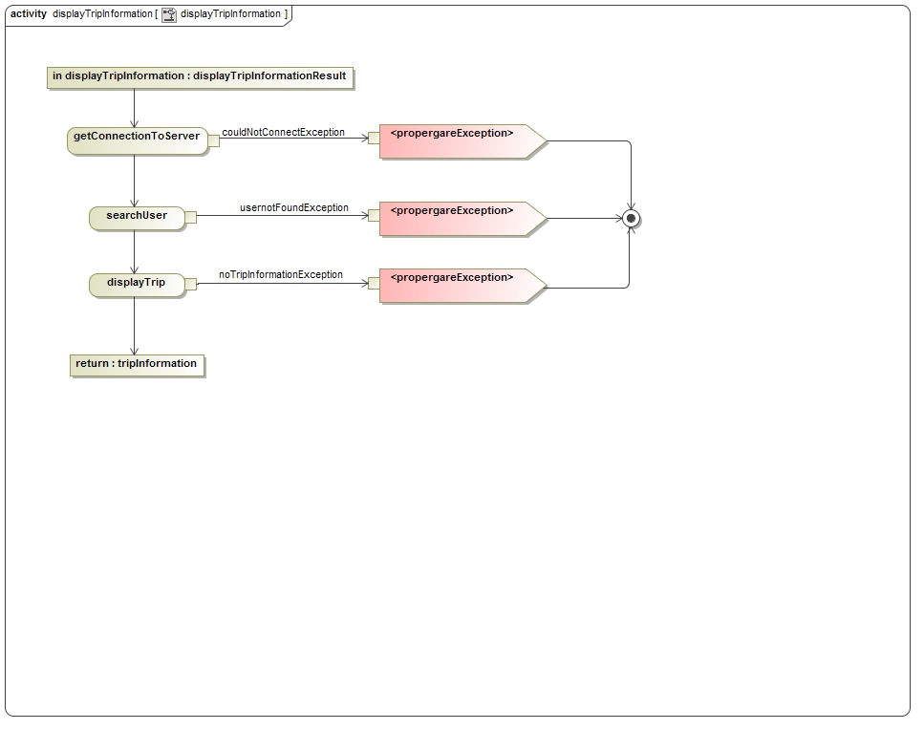

Figure - Display Trip Information process specification

## Nice-To-Have

### viewComparedResults

#### Description

This use case describes the mechanism by which the user will be able to compare their trip information against that of their “Friends”.

#### Use case

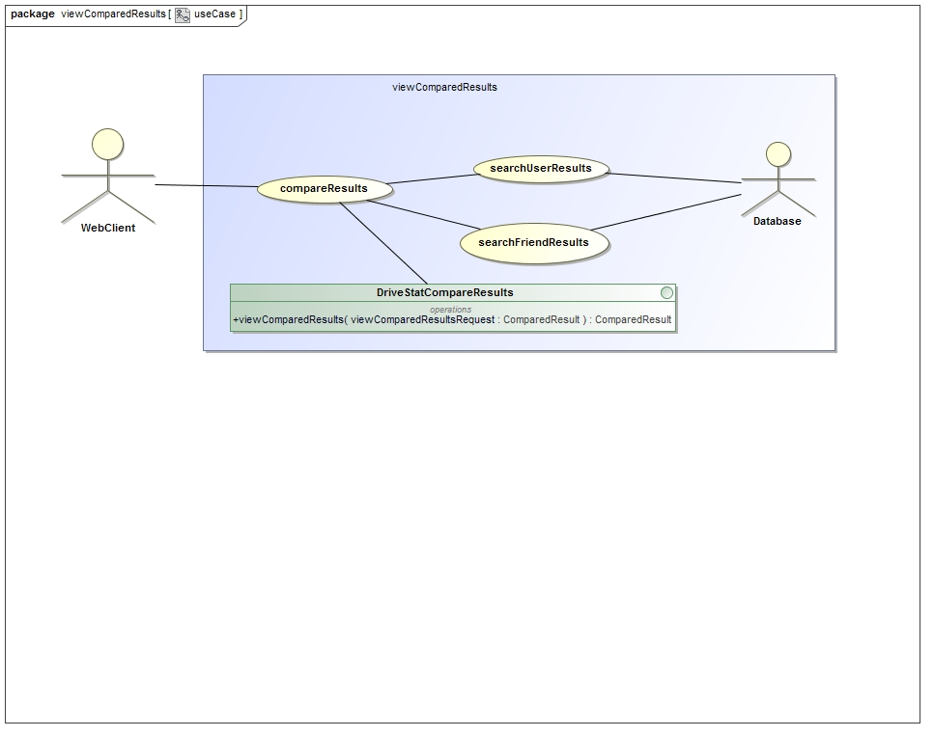

Figure - View Compare Results use case

#### Service contract

This service contract describes the mechanism by which the user will compare their trip information against that of their “Friends”.

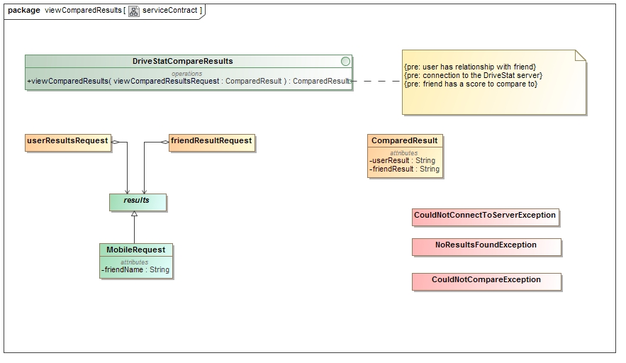

Figure - View Compare Results Service Contract

#### Process specification

This process specification describes the mechanism by which the user will be able to compare their trip information against that of their “Friends”.

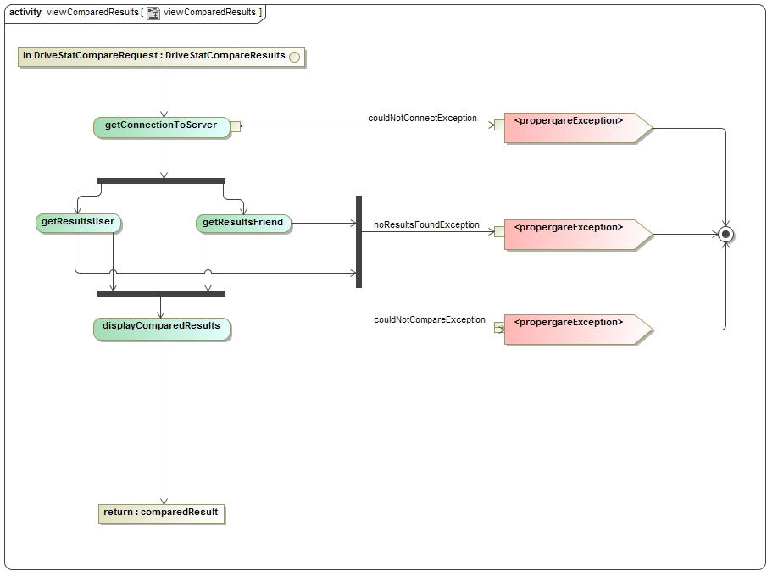

Figure - View Compare Results Process specification

May 2015

|  |  |  |  |  |  |  |
| --- | --- | --- | --- | --- | --- | --- |
| Sunday | Monday | Tuesday | Wednesday | Thursday | Friday | Saturday |
|  |  |  |  |  | 1 | 2 |
|  |  |  |  |  |  |  |
| 3 | 4 | 5 | 6 | 7 | 8 | 9 |
|  |  |  |  |  |  |  |
| 10 | 11 | 12 | 13 | 14 | 15 | 16 |
|  |  |  |  |  |  |  |
| 17 | 18 | 19 | 20 | 21 | 22 | 23 |
|  |  |  |  |  |  |  |
| 24 | 25 | 26 | 27 | 28 | 29 | 30 |
|  | Develop core functionality of server and app |  |  |  |  |  |
| 31 |  |  |  |  |  |  |
|  |  |  |  |  |  |  |

June 2015

|  |  |  |  |  |  |  |
| --- | --- | --- | --- | --- | --- | --- |
| Sunday | Monday | Tuesday | Wednesday | Thursday | Friday | Saturday |
|  | 1 | 2 | 3 | 4 | 5 | 6 |
|  | Obtain test data | Develop Score algorithm and interfaces |  |  |  |  |
| 7 | 8 | 9 | 10 | 11 | 12 | 13 |
|  |  | Testing and Documentation updating |  |  |  |  |
| 14 | 15 | 16 | 17 | 18 | 19 | 20 |
|  |  |  |  |  |  |  |
| 21 | 22 | 23 | 24 | 25 | 26 | 27 |
|  |  |  |  |  |  |  |
| 28 | 29 | 30 |  |  |  |  |
|  |  |  |  |  |  |  |
|  |  |  |  |  |  |  |
|  |  |  |  |  |  |  |

# Bibliography

DVT, 2015. *DVT DriveStats,* s.l.: DVT.